30.25: a) 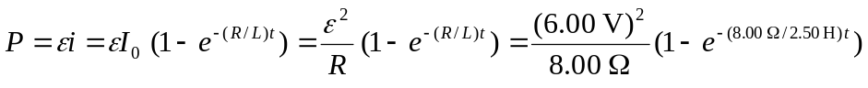
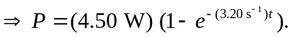
b) 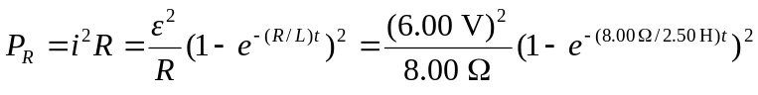
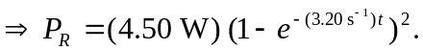
c) 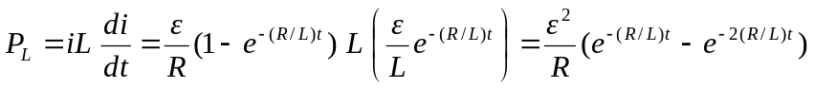
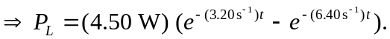

d) Note that if we expand the exponential in part (b), then parts (b) and (c) add to give part (a), and the total power delivered is dissipated in the resistor and inductor.

